Dr.Mamdouh Almustafa 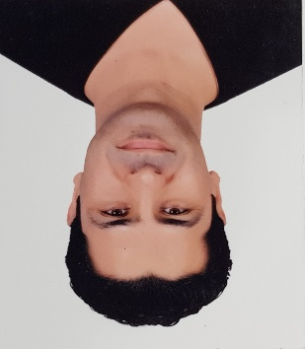
DOB:26/06/1983 ALKUWAIT
Nationality: SYRIAN.
Email: d.mamdouh_mustafa@yahoo.com
Mobile: +974-77316089.
+974-50150608.
Educational Qualifications:
Degree 1: Bachelor of Medicine
Aleppo University, Syria
(2002-2008).
Degree 2: Arab Board in Anesthesia & ICU
Hamad Medical Corporation
(2011-2015).
Degree 3: Neurasthenia Fellowship
Hamad Medical Corporation
(2016-2018).
Anesthesia & ICU Consultant 2019 till now.

Arabian Horses activity:
Beside being a rider & breeder.
- December 2018: Judging workshop (Dr.Marek Trella & Ms. Claudia Darius).

- November 2019: Judging workshop (Dr.Marek Trella & Ms. Claudia Darius).

- 27&28 November 2020: COMPLETING A Course of Instruction in Judging Arabian Show Hearses /Under Qatar Racing & Equestrian Club. (Dr.Mohamad Machmoum & Ms. Renata Schibler).

Judging Probations:

6th Qatar National Arabian Peninsula horses for individual Owners (Mrs. Stigler Irina).
- 23rd Qatar National Arabian Horse Show( Mr. Reisel Gideon).

1st Qatar Arabian Breeders Cup (Mr. Bialobok Jerzy).

